**Adding a role-playing dimension**

**Overview**

In the exercise *Adding a role-playing dimension,* you were asked to configure the **Date** table as a role-playing dimension for the **order date** and **shipping date**. Your task was also to create a measure to calculate the total sales for August based on the **shipping date** by using the **USERELATIONSHIP** function in **DAX**.

Your tasks in this exercise were to:

* Download and connect to the required dataset.
* Create an active and inactive relationship between the **Sales** and the **Date** table.
* Create a measure within your data model by overriding the default relationship.

This reading provides you with a step-by-step guide for completing these tasks. It also includes screenshots that you can compare against your work.

You can also review [*Creating quick measures*](https://www.coursera.org/learn/data-modeling-in-power-bi/lecture/xZZBs/creating-quick-measures) and [*Creating custom measures with DAX*](https://www.coursera.org/learn/data-modeling-in-power-bi/lecture/m25v9/creating-custom-measures-with-dax).

**Step 1: Download and connect to the Adventure Works dataset.**

1. Download and save the workbook **Adventure Works Date.xlsx**. The workbook contains two tables of data: **Sales** and **Date**. The **Sales** sheet contains several columns such as **ShippingDate** and **SalesAmount** which can be viewed by using the scrollbar.

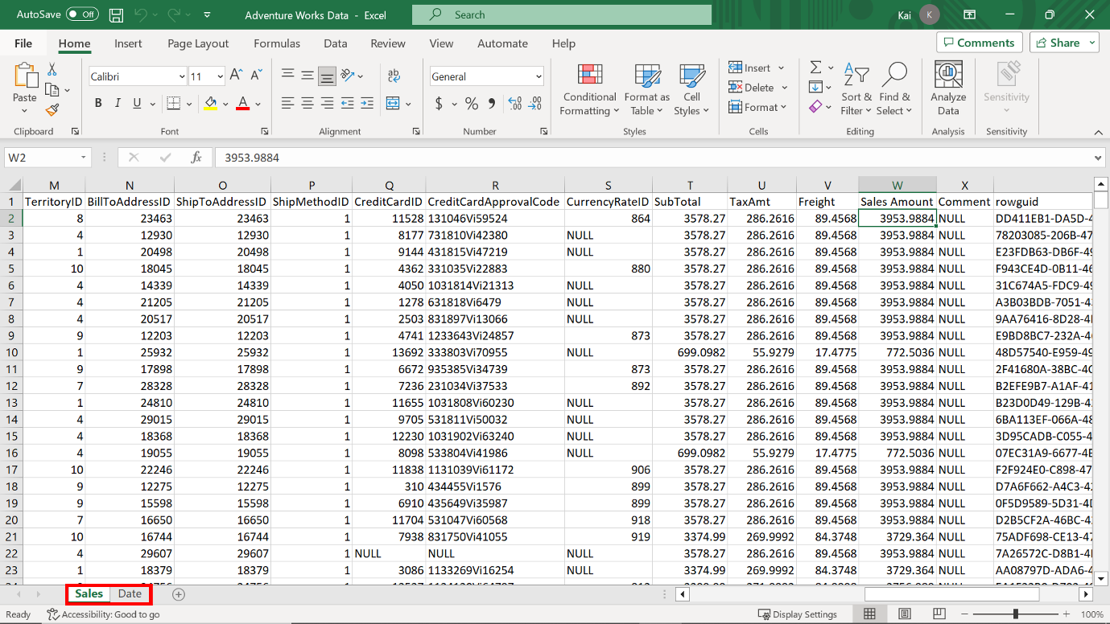

2. Load the data to **Power BI,** ensuring you load both data tables available in the workbook to the data model, that is the **Sales** table and the **Date** table.

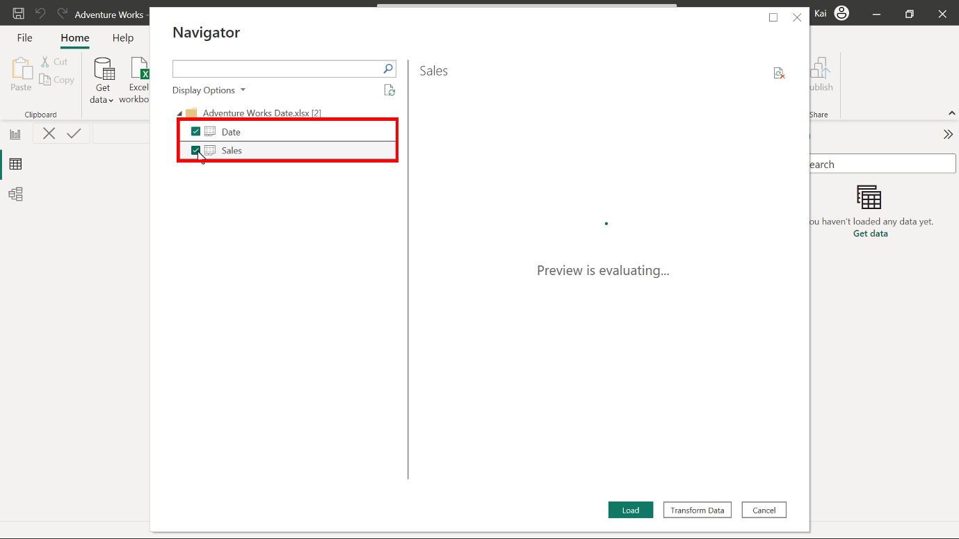

**Step 2: Review the data model and establish relationships.**

1. Ensure an appropriate relationship between the **Sales** table and the **Date** dimension table is established.

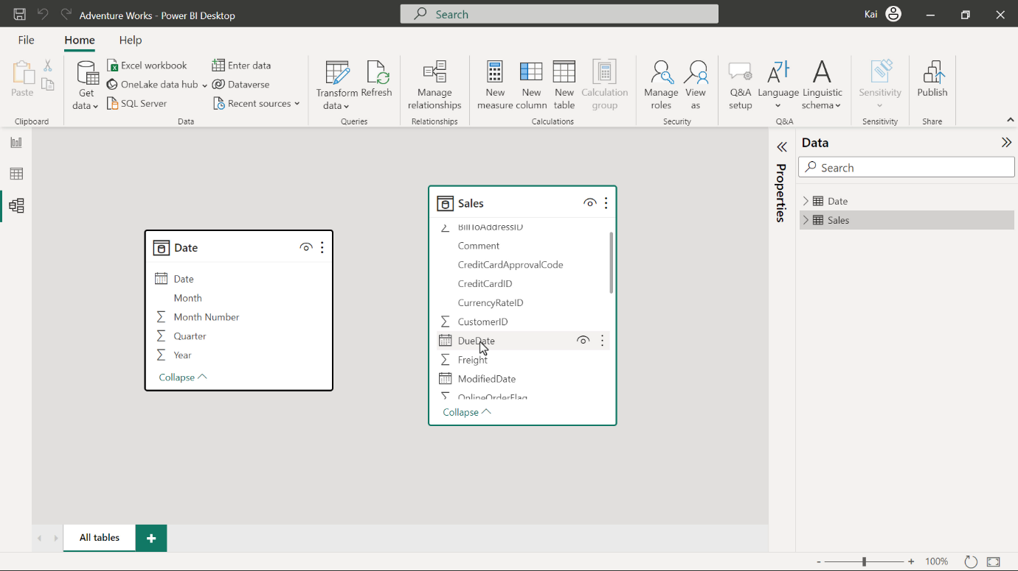

After you Load the data, **Power BI** attempts to establish the relationship between the tables. If the relationship is missing, create a manual relationship between the sales and date table based on the order date. That is the active relationship.

You can drag and drop the **Date** field from the **Date** table to the O**rder date** field in the **Sales** table. Alternatively, navigate to **Manage relationship** option from the **model view** of **Power BI** desktop. This opens the **Manage relationship** dialog box. Select **New** to create a new relationship.

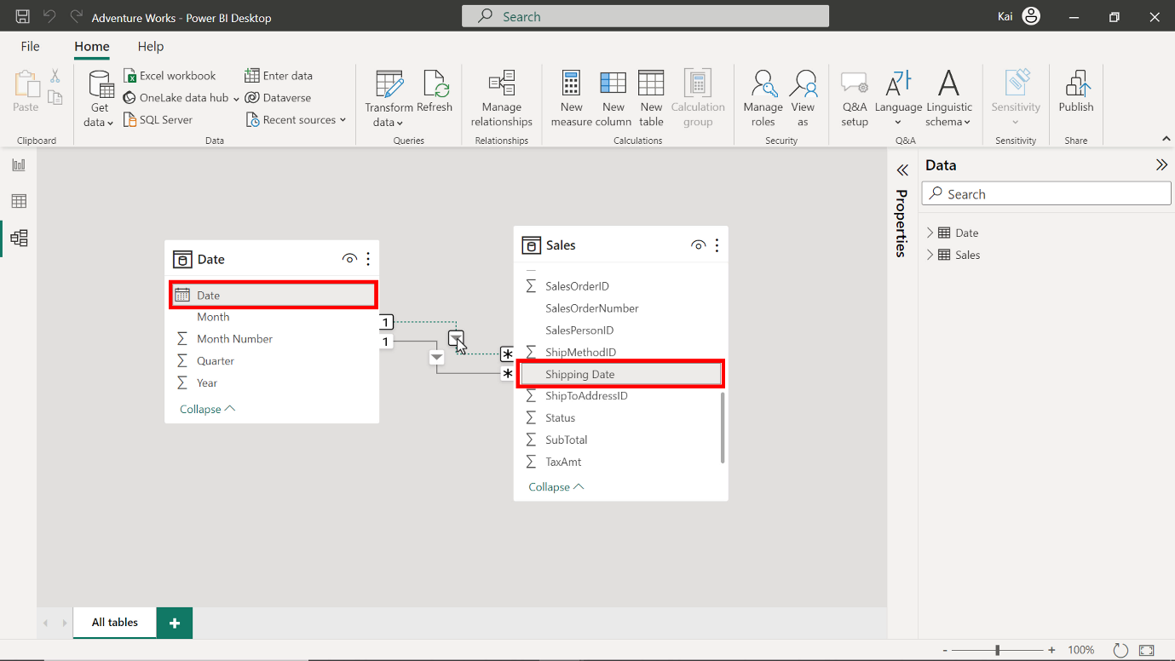

1. Create another relationship between the **Shipping date** field from the **Sales** table and the **Date** field from the **Date** table. This must be an inactive relationship as the Date table is the role-playing dimension in the data model.

You can repeat the drag-and-drop process. Select the **Shipping date** column from the **Sales** table, then drag and drop it to the **Date** column of the **Date** table. The dashed line between the **Date** and the **Sales** table represents this relationship.

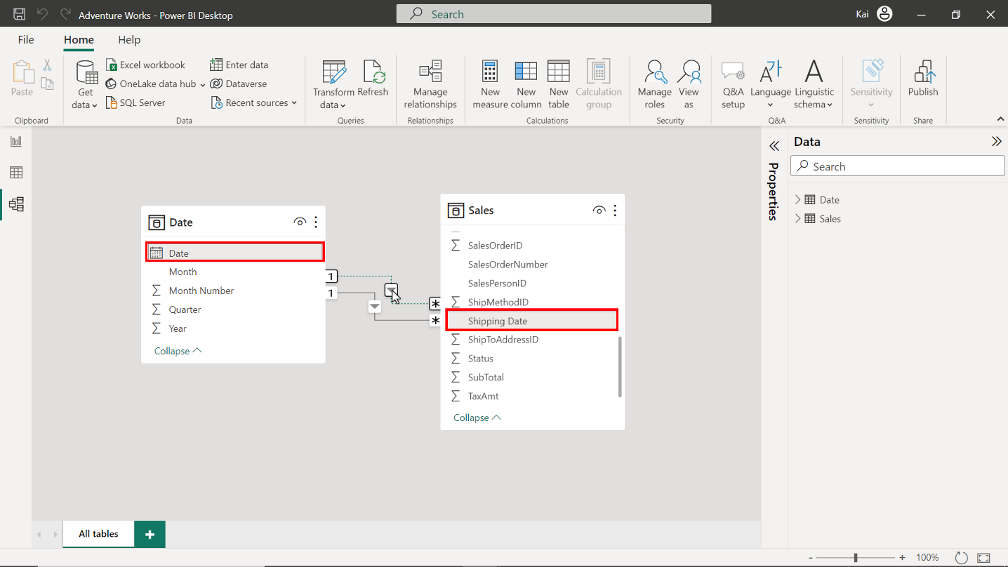

**Step 3: Create Measure by writing DAX expression.**

1. Once you configure the **Date** table as a role-playing dimension and establish the relationship in the data model, create a new measure on the **Sales** table called **August Sales by Shipping date**.

Go the **Data view.** On the **Data** pane, select the **Sales** table and then the **New measure** option from the **Calculations** group. This action expands the DAX formula bar. Add the DAX expression to compute the measure **August sales by shipping date**.

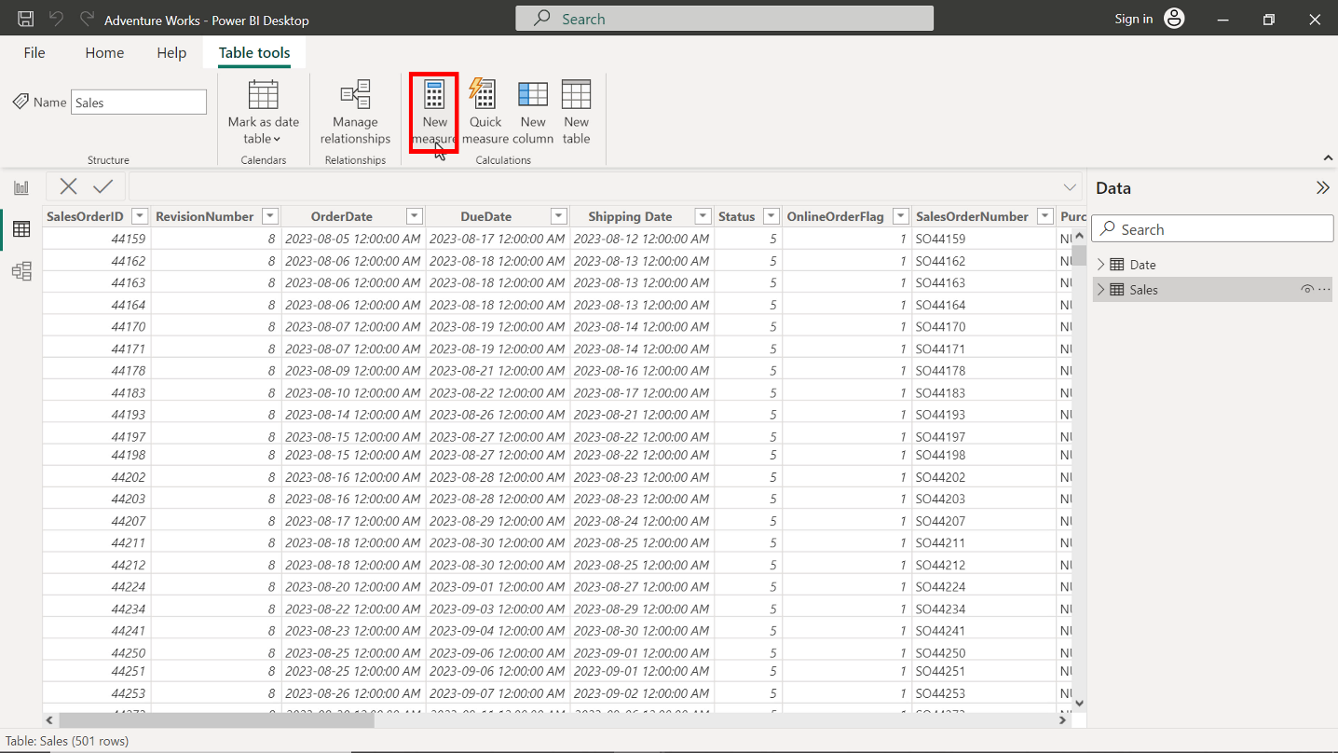

    USERELATIONSHIP(Sales[Shipping Date], 'Date'[Date])

)

(

    SUM(Sales[Sales Amount]),

    FILTER('Date', 'Date'[Month] = "August"),

August Sales by Shipping date =

CALCULATE

* The expression calculates the total sales for August based on the shipping date.
* **SUM** calculates the total **Sales** column from the **Sales** table
* **FILTER** filters the values for August from the **Month** column of the **Date** table
* **USERELATIONSHIP** overrides the table relationship to consider the **shipping** date instead of the **order date,** which is the default relationship.

Once you execute the code, a new measure appears in the data pane under the **Sales** table.

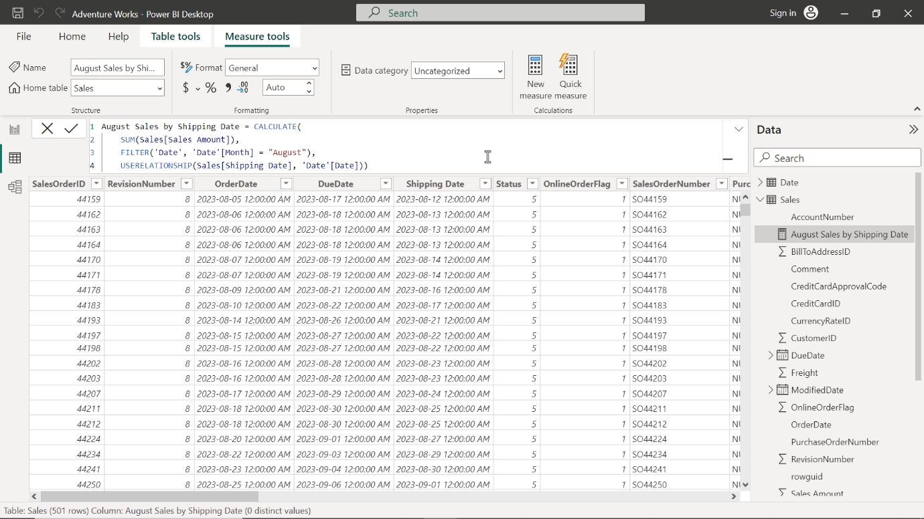

1. Format the measure as currency with 2 decimal places.

To format the measure, select the newly created measure from the data pane. Navigate to the formatting group in the **Measure tools** tab of Power BI. Select **Currency** from the **Format** drop-down menu.

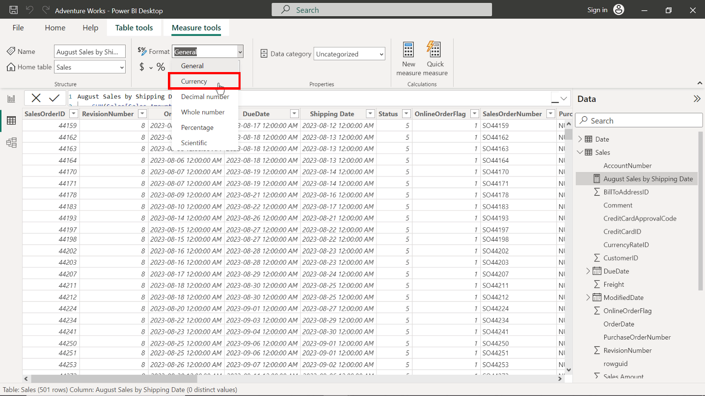

Enter **2** in the decimal places (which is auto by default). This action formats the measure as **Currency** within **2** decimal places and is good for visualization.

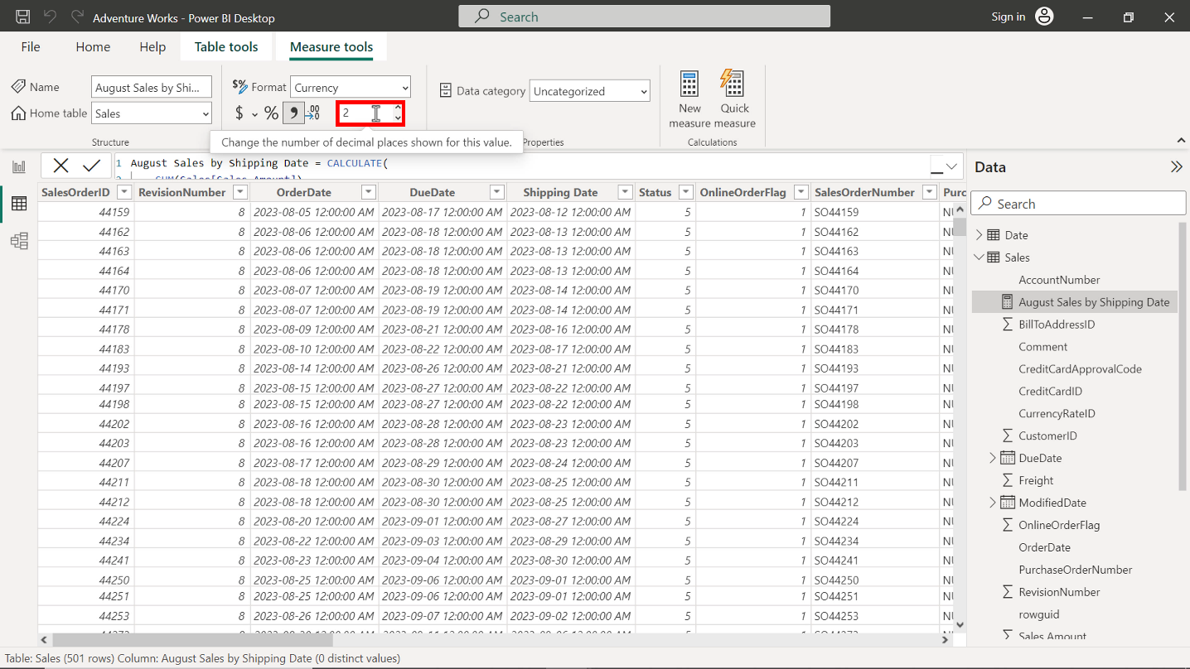

You can view the results of the measure in the following diagram:

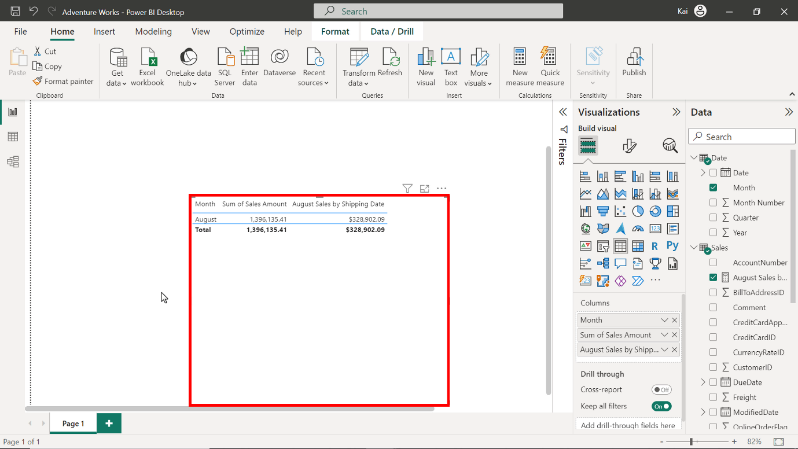

**Step 4: Save the Power BI project.**